# Sprint 4 Plan

**GOAL**: The goal for this sprint is to finish what we missed the last sprint, by getting the site hosted. We also want to make the site look polished.

**User Stories**

Must Have

As a user of the website, I want to be able to access my neural networks across multiple machines.

Task 1: Render Spike

Task 2: Set up account for Render

As someone who is new to neural networks, I want some simple designs to get me started.

Task 1: create front end options for network patterns

Task 2: Allow those front end buttons to create operators on the canvas in the correct spots

**TEAM ROLES**

Nicolas Ayala PO, SM

Anish Pahilajani

Kat Negrete

Mahesh Vegiraju

Alex Hutchins

**INITIAL TASK ASSIGNMENT**

Nico: Render spike

Alex: Add options for network patterns

Kat: Test pytorch code generation over variety of networks

Mahesh: Render spike

Anish: Test tensorflow code generation over variety of networks

**BURNUP CHART**

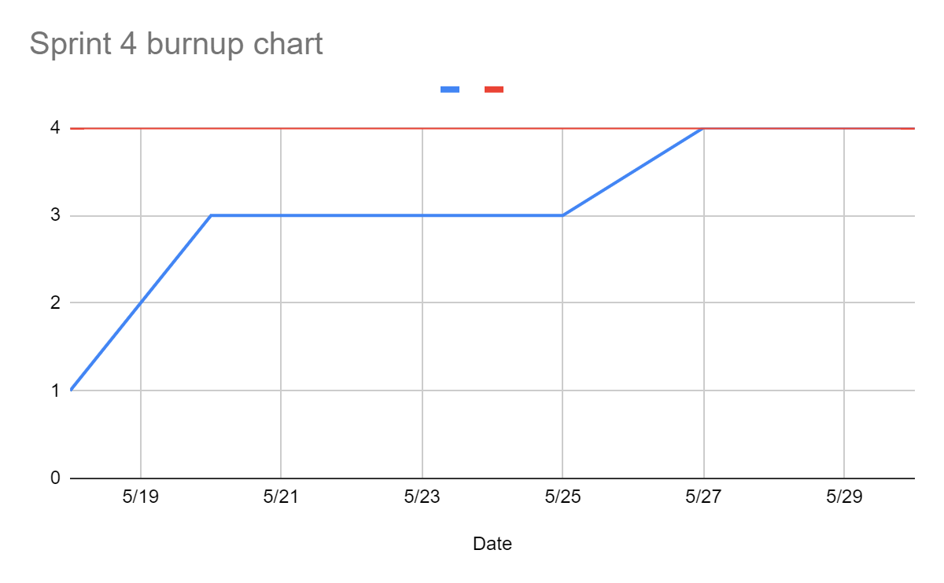

**SCRUM BOARD**

[**https://trello.com/b/rCguSS4M/sprint-4**](https://trello.com/b/rCguSS4M/sprint-4)

**SCRUM TIMES**

**mon-wed-fri afterclass**